European Petanque Championships
19-21 August in Gothenburg

Group G

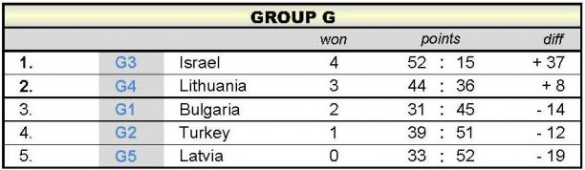
Bulgaria – Turkey 13-9
Israel – Lithuania 13-5
Bulgaria – Israel 1-13
Turkey – Latvia 13-12
Bulgaria – Latvia 13-10
Turkey – Lithuania 9-13
Bulgaria – Lithuania 4-13
Israel – Latvia 13-1
Turkey – Israel 8-13
Lithuania – Latvia 13-10

